|  |
| --- |
| nopCommerce – Live Project |
| **Project Functional Requirement Specification Version 1.0** |
|  |
| **Prepared by: Ram Prasad G**  **Reviewed by: Raghavendra BN** |
|  |

Contents

1. Purpose of the Document: 3

2. Project Overview: 3

2.1 Audience: 3

2.2 Hardware and Software Requirements: 3

3. Information Architecture 4

3.2 Login 6

3.3 Add to Cart 7

3.3.1 Billing Address 8

3.3.2 Shipping Address 9

3.3.3 Shipping Method 10

3.3.4 Payment Method 11

3.3.5 Payment Information 12

3.3.6 Confirm Order 13

3.4 Delete from Cart 14

4. Sign-Off Document 15

# Purpose of the document:

nopCommerce is the best open-source e-Commerce shopping cart solution. nopCommerce is free, and it is the most popular ASP.NET e-Commerce platform. The first nopCommerce version was released in 2008. At that time there were no free and open-source shopping carts that would not impose the limitations on business processes and flow hence the essential goal for nopCommerce was to fix that.

The high quality of the product and its constant development led to creating the global nopCommerce community of over 250,000 members. The philosophy of the open-source product allows us to receive the contribution of developers and businesses from around the world. That helps us to grow faster and meet the highest security and technology standards.

# 2. Project Overview:

## 2.1 Audience:

This document is intended as a complete guide for user who is using nopCommerce. This document is specially designed for the user as a useful point of reference. By reading this guide, you will learn how to use nopCommerce through the elements of the graphical user interface and what's behind some of the advanced features that are not always obvious at first sight. It will hopefully guide you around some common problems that frequently appear for users of nopCommerce.

## 2.2 Hardware and software requirements:

**Supported operation systems**

Windows 7 or above

Windows Server 2008R2 or above

## Supported browsers

Microsoft Internet Explorer 9 and above (IE6 and IE7 were supported in versions prior 3.60, IE8 was support in versions prior 4.10)

Mozilla Firefox 2.0 and above

Google Chrome 1.x

Apple Safari 2.x

**Hardware Requirements**

Computer, Mobile, Internet

# 3. Information Architecture

**3.1 Registration**

User can register into nopCommerce by providing personal details like name, Email, Country as shown in figure 1, figure2, figure3. User has to set username and password to use them as login credentials.

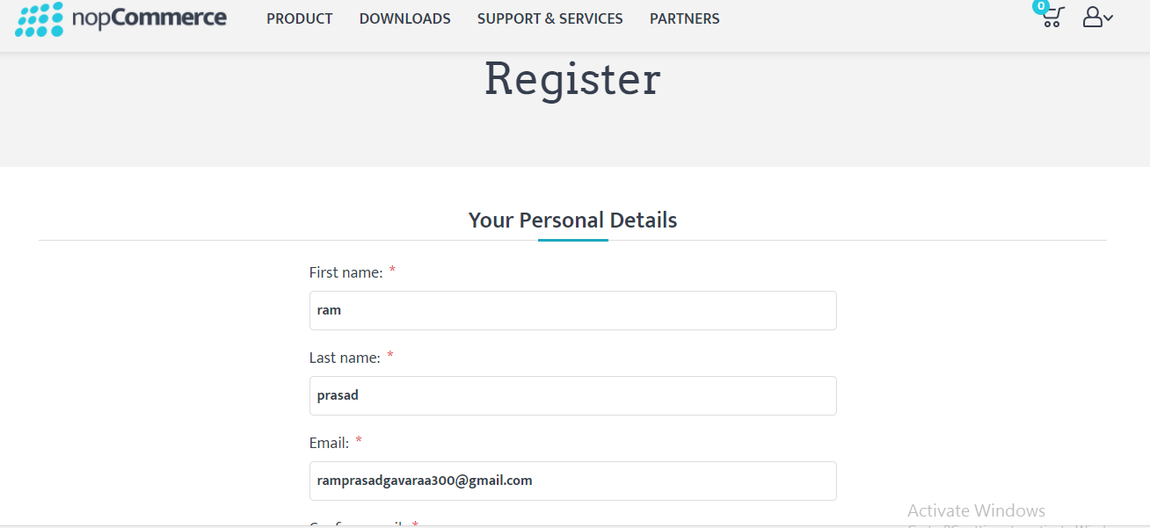

Figure 1

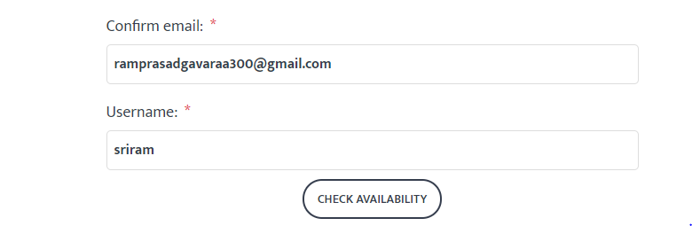

Figure 2



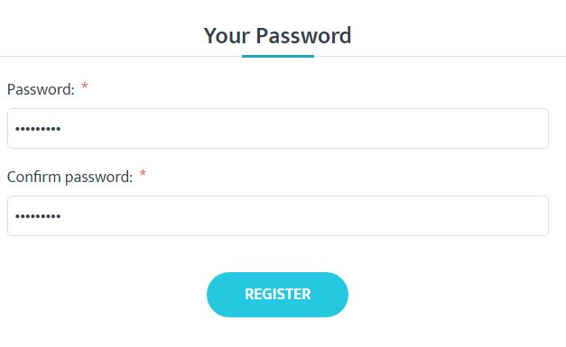

Figure 3

## 3.2 Login

User can login by using the credentials given while registering into the page as shown in figure 4.

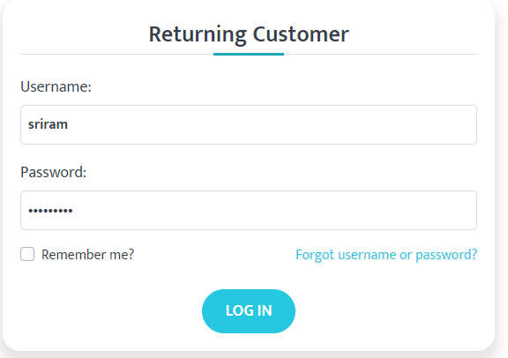

Figure 4

## 

## 3.3 Add to Cart

There are many categories such as Electronics, Computers, Apparel, Books, Jewellary, Digital downloads, Gift cards as shown in figure 5. User can select the required category and shop for the products by adding them into cart. Any number of items can be added into cart at the same time.

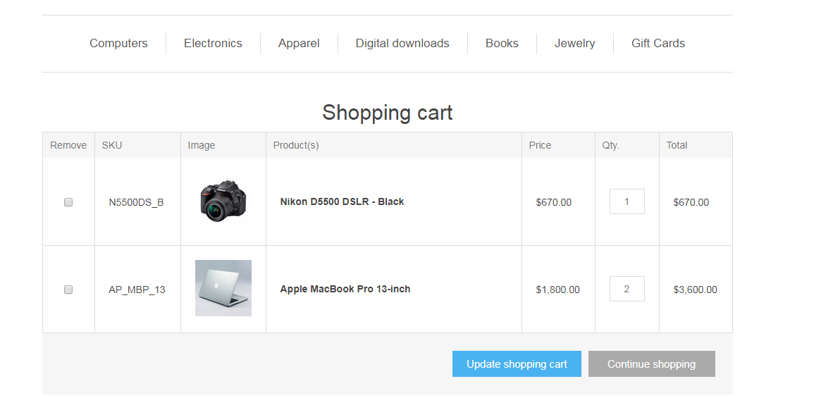

Figure 5

### 3.3.1 Billing Address

In Billing address User can add the address of location where the item in his cart has to be delivered. As shown in figure 6, figure 7 User should provide details like name, Email, Country, State, street name and pin code of the city and mobile number to reach out for any queries.

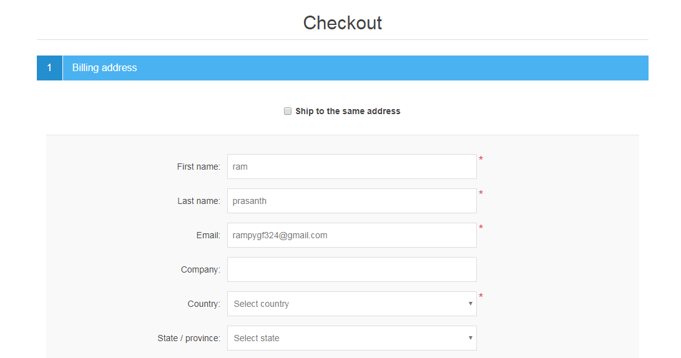

Figure 6

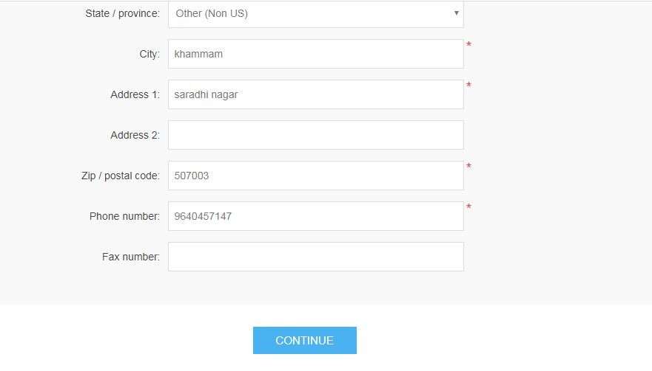

Figure 7

### 3.3.2 Shipping Address

If billing address is same as shipping address then we should tick the check box while entering the billing addressas shown in figure 6. If it is different as shown in figure 8, select new address option from the dropdown enter the address of the location so that the item will be delivered to the required location.

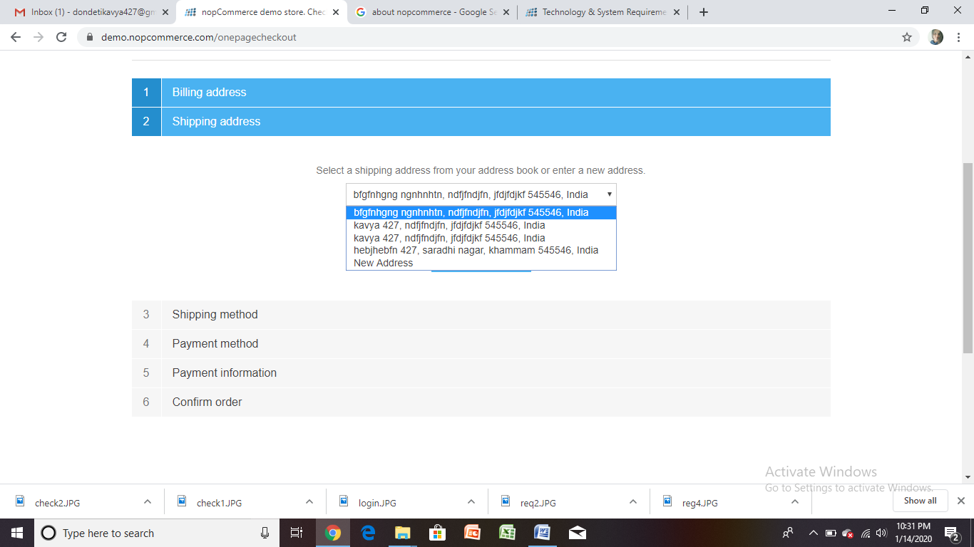

Figure 8

### 3.3.3 Shipping Method

In this the user will have three options Ground, Next Day Air, Second Day Air as shown in figure 9. Ground is for road transport shipping, Next Day Air is for one day air shipping and the Second Day Air is for shipping by air in 2 days. The user can choose any one of the options based on his requirement.

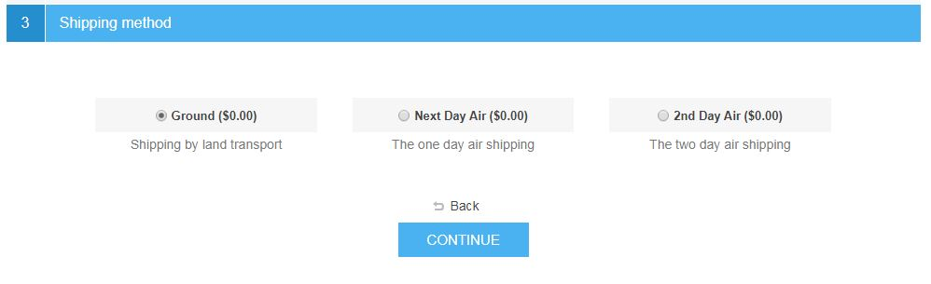

Figure 9

### 3.3.4 Payment Method

Here the user can select either cash on delivery or pay through debit or credit card as shown in figure 10 and then click on continue to proceed further.

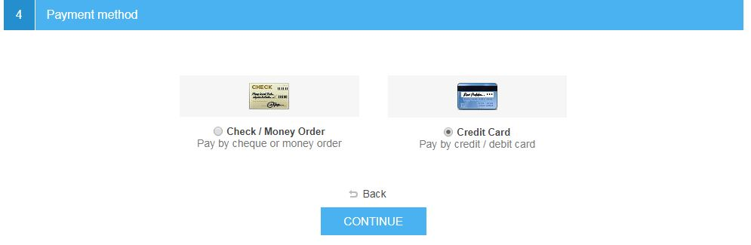

Figure 10

### 3.3.5 Payment Information

If payment mode selected is card then we need to enter the card details such as card holder name, card number, expiry date and CVV as shown in below figure 11 and click continue. If cash on delivery mode is selected then it is directly redirected to confirm order.

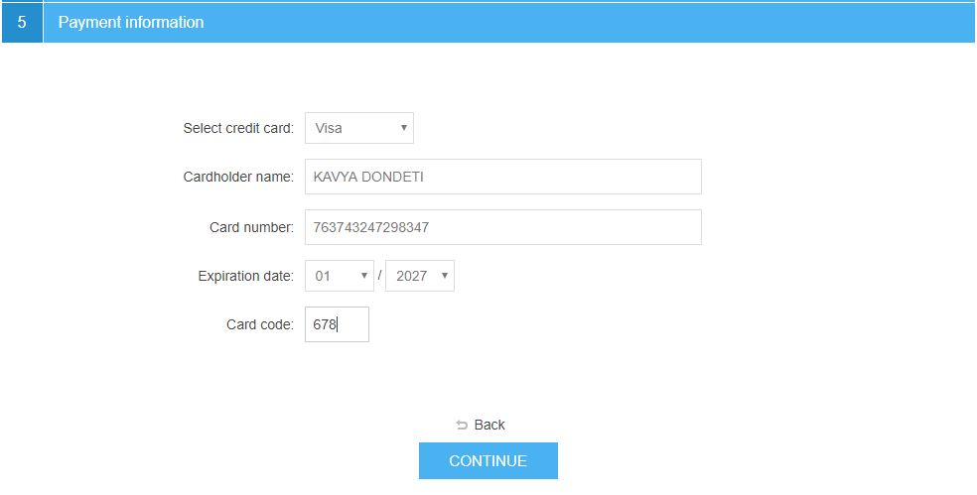

Figure 11

### 3.3.6 Confirm Order

After entering all the details we get to confirm order status where all the billing address and shipping address will be displayed and also the order details as shown below in figure 12. Here once check if the details provided are correct and then click on confirm order.



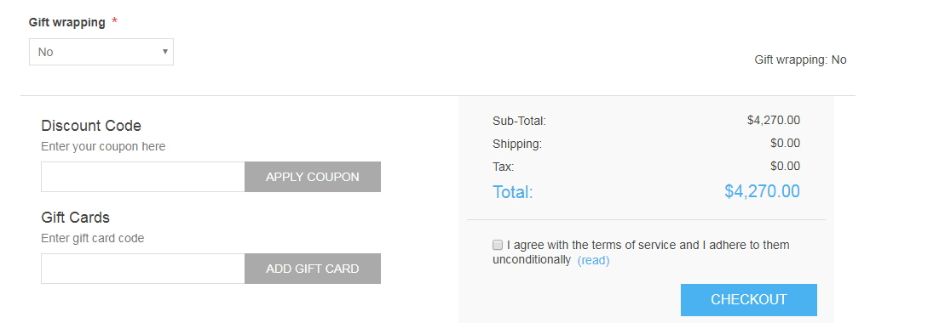

Figure 12

### 

### 3.4 Delete from Cart

We can remove the items added into the cart any time we want by clicking on the checkbox below remove and then click on update shopping cart as in the below figure 13 .



Figure 13

# 4. Sign-Off Document

_____________________________________________________________________________

The following parties have read and agree with this Requirements Definition document for the nopCommerce application account module functionality.

After approval of this Requirements Definition phase, any significant changes in the scope of this project will require validation of existing project costs and schedules.

_______________________________________________________________________

Name Date

Business Lead

______________________________________________________________________

Name Date

Project Manager

**Prepared by: Ram Prasad G**